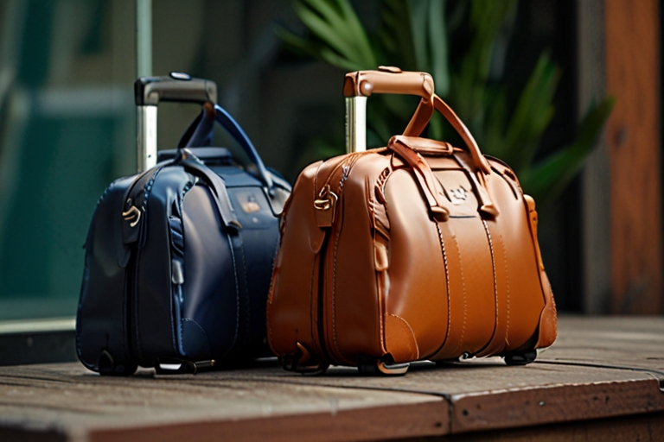

|  |  |
| --- | --- |
|  | Title: Strategic Resilience and Market Adaptation: Roamster's Journey in the Luxury Luggage Segment |
|  | Student No: 23089900 |
|  | Module No: BST715  Word Count: 2180 |

**Table of contents**

|  |  |  |
| --- | --- | --- |
| Sr No. | Section | Pg No. |
| 1 | **Executive Summary** | **3** |
| 2 | **Introduction** | **3** |
| 3 | **Discussion** | **5** |
| 4 | **Conclusion** | **14** |
| 5 | **Recommendation** | **15** |
| 6 | **Appendices** | **16** |

**Table of Figures**

|  |  |  |
| --- | --- | --- |
| Sr No. | Figure | Pg No. |
| 1 | **Organizational Chart** | **4** |
| 2 | **Sales and Production Data** | **6** |
| 3 | **Financial Performance Comparison** | **8** |
| 4 | **Brand Awareness and Product Rating Q1 to Q4** | **10** |
| 5 | **Financial Performance Improvement** | **13** |
| 6 | **Net Income from Q1 to Q6** | **14** |

**Executive Summary**

Roamster, a century-old luggage company, faces challenges with brand clarity and price sensitivity in the luxury segment. Despite this, it has made significant financial progress by realigning strategies to increase market share and brand awareness. By focusing on innovative cabin cases and versatile briefcases, and optimizing sales strategies, the company has effectively adapted to market demands.

Additionally, Roamster's shift towards sustainability in response to the End-of-Life Plastics (EoLP) directive has improved its environmental reputation, aligning with consumer preferences for eco-friendly products.

These comprehensive adjustments in product development, marketing, and supply chain have strengthened Roamster's position for future growth and sustainability, showcasing its commitment to innovation, environmental stewardship, and market responsiveness.

**Introduction**

In a world where luggage often seems to possess more personality than the average traveller, Roamster has carved out its niche over the past century. Known for its innovative cabin cases, versatile holdalls, and luxury briefcases, Roamster operates under the visionary motto, "Empowering journeys globally with innovation, elegance, and responsibility." This report examines Roamster’s market position and strategic manoeuvres to address challenges such as limited vendor diversity, unclear brand positioning for holdalls, and high price sensitivity in the luxury segment. Despite these obstacles, Roamster continues to boast a loyal customer base. Conducted under time and data constraints, the analysis identifies strategic opportunities for growth and improvement.

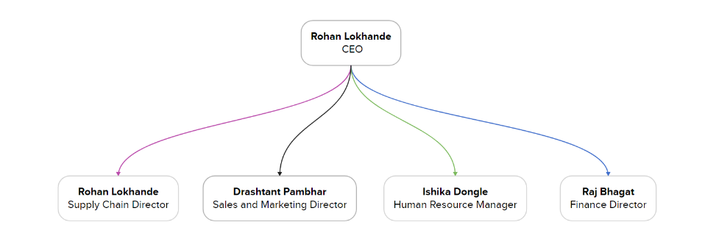

**Figure 1: Organizational Chart**

Roamster's executive management team, including CEO and Supply Chain Director Rohan Lokhande, Sales and Marketing Director Drashtant Pambhar, HR Manager Ishika Dongle, and Finance Director Raj Bhagat, rotates the CEO role among members to foster diverse leadership and strategic thinking.

**Discussion**

The discussion evaluates Roamster's strategic adjustments, focusing on product enhancement, marketing optimization, and supply chain refinement. It highlights the impact on financial performance, market share, and operational efficiency, demonstrating Roamster's adaptability in a competitive industry.

**Quarter 1: Initial Gains**

In the first quarter, Roamster's share price stood at £20.24. The company had invested 72.50% in future initiatives and made efforts to enhance brand awareness at 72.54%. Product satisfaction was recorded at 67.50%.

Roamster prioritized its foundational cabin cases due to historical alignment and market demand. Briefcases were the second priority due to profitable margins, while holdalls received less focus, mainly because of weaker sales outside the Asia Pacific region. The company aimed to capitalize on strong potential in Asia Pacific, followed by the EMEA region, and to expand in Latin America while maintaining its North American presence. The business target was ambitious, aiming for £161.4 million in revenue and £23.7 million in net profit.

From a staffing perspective, Roamster optimized its sales personnel to align with regional strategies and maximize market penetration. The table below details the adjustments made to sales personnel, production volumes, production capabilities, and inventory data for each product line.

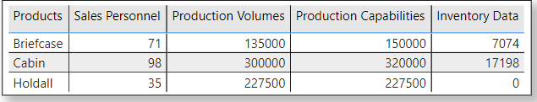

**Figure 2: Sales and Production Data**

Additionally, regarding supply chain management, the production for cabin cases was kept at 300,000 units, balanced against an inventory of 17,000 units from the previous period and a production capacity of 320,000 units. Holdalls, with no units carried over, were produced at full capacity to replenish stocks. Briefcase production was adjusted to 135,000 units, considering the 7,000 units in reserve. Furthermore, two new production lines for holdalls were acquired at £152,500 per thousand units to meet anticipated demand.

Financially, Roamster reported £146.9 million in revenue for the quarter, with a cost of sales at £74.6 million, yielding a gross profit of £72.2 million and a gross margin of 49.15%. Net income was £21.5 million, and total assets were valued at £517.8 million, ensuring financial stability and a foundation for future growth and profitability.

**Quarter 2: Building Momentum**

In Q2, the company focused on strategic segments and regions, setting a revenue target of £177.9 million and a profit goal of £26.1 million. This was underpinned by a product development strategy to enhance the market ratings of the Briefcase and the Cabin, which stood at 75% and 83% respectively. For each product we spend £5 million for research and development to improve investment in the future. We introduce multi-features and expand colour ranges, resulting in cost prices of £151.40 for the Cabin and £179.20 for the Briefcase. The Holdall, already well-rated, was improved with new features, leading to a cost of £77.10.

The company increased its marketing spend to £2.44 million to boost brand awareness, focusing on magazines, ads, and billboards, affecting product pricing. The Cabin price was adjusted from £225 to £219, the Holdall from £120 to £109, and the Briefcase from £395 to £399.

Sales strategies still prioritized the Asia Pacific and EMEA markets due to growth potential. Sales staffing was adjusted to 110 for the Cabin, 51 for the Holdall, and 74 for the Briefcase. In HR, employee morale was enhanced by raising the average salary from £58,000 to £60,000 and the bonus from £11,700 to £12,000. Sales development and product training programs were implemented for skill development and career progression.

Supply chain adjustments included a 10-line increase for the Holdall production due to an 8,072-unit stock-out, setting its production at 227,500 units. Production capacities for the Briefcase and Cabin were maintained with modest line increases.

Financially, the company posted £147.5 million in revenue and a gross profit of £72.4 million, equating to a 49.08% gross margin, with a net income of £21.6 million. The share price was £20.47, indicating a positive market response to the company's strategies.

**Figure 3: Financial Performance Comparison**

As the quarter concluded, the key question was whether these strategic decisions would sustain the upward trajectory in revenue and profit. Given the enhancements in product development, marketing, sales, HR, and supply chain management, the company is optimistic about the upcoming quarter's success.

**Quarter 3: Strides and Struggles**

In the third quarter, the organization implemented strategies to increase market share and improve brand awareness, resulting in market share rising from 24.88% to 27.03% and awareness levels reaching 82.7%. Despite these gains, product quality remained unchanged at 83.7%.

Financially, the quarter was challenging, with share prices dropping from £20.47 to £5.59. Revenue was steady at £147.8 million, but higher costs of sales at £89.3 million reduced the gross profit to £58.5 million. The gross profit margin fell to 39.58%, below the industry standard of 48%. Net income also plummeted from £21.6 million to £5.08 million.

Operationally, the company adjusted its pricing due to increased costs: cabin bags at £249, holdalls at £125, and briefcases at £409, with respective cost prices of £167.80, £82.40, and £208.80. These changes-maintained competitiveness by offering more features at lower prices than competitors.

Marketing efforts were optimized, reducing costs from £2.44 million to £1.91 million. In sales, strategic adjustments aligned staff with demand: cabin sales staff decreased from 110 to 100, while holdall and briefcase staff increased from 51 to 60 and 74 to 77, respectively.

Human resources remained strong, with the highest employee satisfaction rate among competitors at 93.81%. The average salary increased by £2,000 to £62,000, but bonuses were reduced to £8,500.

However, supply chain issues led to stockouts across all products due to zero inventories. The company responded by maximizing production volumes and increasing lines, but couldn't meet the surge in demand, resulting in stockouts of 34,000 units for cabins and holdalls and 701 units for briefcases.

Despite supply and financial setbacks, the organization is poised for recovery. The next quarter will focus on resolving supply chain issues and restoring financial stability, leveraging strong market share and brand awareness.

**Quarter 4: Strategic Recovery**

In Q4, the organization navigated a complex landscape, aiming to regain financial stability while enhancing product quality and market positioning. Market share slightly decreased to 25.77%, with the briefcase segment dropping to 23.92%. Despite this, strategic enhancements raised the product rating to a record 92.7%, well above competitors, and achieved a price score of 89.6%. However, brand awareness dipped to 78.7%.

**Figure 4: Brand Awareness and Product Rating Q1 to Q4**

To address financial challenges, the company revised its pricing strategy, raising the prices of cabin bags, holdalls, and briefcases to £259, £139, and £439, respectively, while reducing production costs to £163.30, £67.50, and £200.35 to maximize profits and cut R&D spending.

Roamster secured £5 million in investment, allocating £695,000 to product development to enhance material quality and add personalized options, improving product ratings by 9%. An additional £1.6 million was used for sponsorship deals and social media campaigns, boosting brand awareness by 10.5%.

Sales were strong for cabins and holdalls, with 331,726 and 258,369 units sold, but briefcase sales lagged at 133,785 units, prompting an increase in sales personnel for this segment. HR adjustments-maintained salaries at £61,000, increased bonuses to £15,000, and optimized training to balance resource use.

Supply chain challenges resulted in stockouts of 13,498 cabins and 25,951 holdalls. Adjustments in production capacities and a £600,000 quality initiative were implemented to improve material use and stitching, expected to save £600,000 quarterly from Q5. Contract manufacturing was expanded, increasing costs by 8% and risking a 2% drop in briefcase quality for a £150,000 setup fee.

Financially, the company saw improvements: share prices rose to £9.64, and revenue increased to £163 million, though the gross profit margin remained low at 38.34%. Net income grew to £9.99 million. Total liabilities and equity reached £542.5 million due to factory expansions, with net cash flow steady at £68.6 million.

Overall, the strategic use of £3.04 million from the £5 million investment aims to boost profitability and efficiency, promising increase in future profits.

**Quarter 5: Rising Responsibly.**

In Quarter 5, the organization proactively responded to the new End of Life Plastics (EoLP) directive, mandating that 95% of luggage plastic by weight be reused, recycled, or recovered. This affected cabin and holdall products, which now require processing through Authorized Treatment Facilities (ATF). By leveraging the Global Luggage Manufacture Association’s (GLMA) Recycling Return Network (RRN), the company adopted sustainable practices and benefited from economies of scale, reducing costs.

This quarter marked a strategic pivot toward environmental sustainability, aiming to "Revolutionize travel with innovative, eco-friendly bags." Market share rose to 26.14%, aided by strong marketing that increased brand awareness to 84.9%. Despite cost-cutting and price hikes, product quality remained high at 92.1%, thanks to continued investment in quality initiatives.

The product focus shifted, prioritizing briefcases due to their high-profit margins and compliance with EoLP, as they contain no plastic. Cabin products were ranked second and holdalls last. Regionally, EMEA led in performance, with Asia Pacific, North America, and Latin America following.

Product development adapted to EoLP, with the cabin’s cost price at £168.59 containing 917 grams of plastic, and the holdall at £66.57 with 395 grams of plastic. The briefcase’s cost remained stable, containing no plastic. R&D expenditure slightly increased to maintain innovation.

Marketing strategies, with a budget of £2.26 million, emphasized recycling symbols on packaging to align with environmental directives. Sales showed healthy volumes across all segments, with a significant personnel increase for briefcases, indicating the strategic shift. Supply chain issues continued with significant stockouts of cabin and holdall units, expected to resolve next quarter, with production capacities maintained at maximum.

**Figure 5: Financial Performance Improvement**

Financially, the quarter was exceptional, share prices soared to £23.10 from 5.59 in quarter 3, revenue reached £172.4 million, and the gross profit margin improved to 44.44%, nearing industry standards. Net income jumped to £22.1 million. With total liabilities and equity at £563.6 million and net cash flow at £85.3 million, the company is robust. Dividends were initiated at £0.16 per share.

Overall, the company's strategic adjustments and proactive approach to EoLP have positioned it strongly in finance and sustainability. Stakeholders are confident in Roamster’s legacy of success and environmental responsibility.

**Conclusions**

Based on the comprehensive analysis of Roamster's performance and strategy, it is evident that the company has adeptly navigated market challenges. By focusing on cabin cases and briefcases, Roamster achieved significant financial growth and a strong market presence.

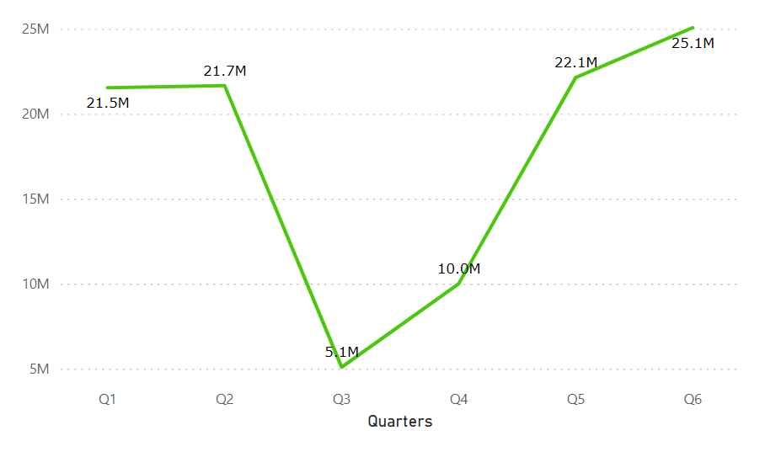

**Figure 6: Net Income from Q1 to Q6**

The company demonstrated resilience, rebounding from a low net income of $5.08 million in Q3 to $25.06 million in Q5, with revenues reaching $184.4 million. Strategic management and product development have enhanced profitability and customer satisfaction, despite operational hurdles such as supply chain issues and stockouts. Additionally, the company needs to address pricing strategy adjustments and enhance inventory management to prevent future stockouts. The adoption of eco-friendly practices and a positive financial trajectory position Roamster well for future growth and investment opportunities.

**Recommendations**

* Roamster should periodically adjust briefcase prices based on market trends and consumer feedback to stay competitive in the luxury segment.
* Roamster should launch marketing campaigns for holdalls, emphasizing their unique features and versatility for travel and everyday use.
* Roamster should intensify marketing and sales in Latin America and North America with localized advertising, retail partnerships, and promotional events to boost brand awareness.
* Roamster should improve its inventory management using predictive analytics to accurately forecast demand and prevent stockouts.
* Roamster should establish a customer loyalty program that rewards frequent purchases and referrals, encouraging repeat business and strengthening brand loyalty.
* Roamster should enhance its after-sales service, offering free repairs, personalized maintenance tips, and a dedicated helpline to reinforce its commitment to quality and customer satisfaction.

**Appendices**

**Volumes of units sold each quarter.**

**Income Statement Q1 to Q5:**

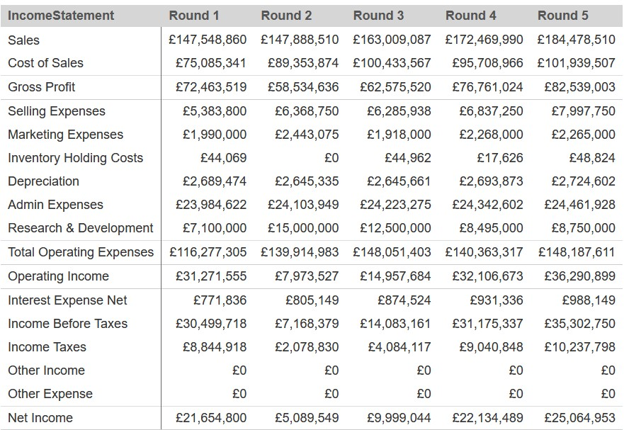

**Balance Sheet Q1 to Q5:**

**Cash Flow Q1 to Q5:**

**At the end of the simulation we came at 3rd place with 94.16  
  
**